Wyandot County Public Health

419-294-3852 | 127-A South Sandusky Ave., UPper Sandusky, OH

Updated 1/25/2023

Temporary Campground Permits

Rules and regulations

**Do I *need* a license?**

**If you have 5 or more camper sites on your property and are charging a fee, you MUST have a temporary campground license.** Temporary campgrounds are campgrounds set up for 7 days or less. Submit plans to Wyandot Co. Public Health AT LEAST 15 days before your event to ensure your plans are approved prior to your event.

**How much is this going to *cost*?**

**The basic license costs $125. Each campsite over 50 will add an additional dollar.** So, say you’re having a huge solar eclipse party with 80 campsites. Your license cost would be $125, plus another $30 for the additional 30 campsites. A grand total of $155.

***Why* do I need a license?**

The Ohio Administrative Code indicates you must have a license. Wyandot County Public Health carries out the licensing process for temporary campsites in Wyandot County. Beyond the legal reasons, **the rules exist to ensure the safety of both you (the licensee) and the campers enjoying their time with you.**

**Okay fine, I’ll do it. How do I get a license?**

1. Find a plot of land you want to use.
2. Fill out the **Temporary Campground Application for Plan Review and License to Operate form (Appendix 1)**, create a **proposed layout (Appendix 2)** and create a **vicinity map (Appendix 3)**.
3. Get **written verification by the fire protection authority (Appendix 4)** or authorities that have jurisdiction in the area (your local fire department) that adequate fire protection can be provided to the campground. A complete list of area fire departments is listed in Appendix 5.
4. **Submit the application, proposed layout, and written verification from the fire department to Wyandot County Public Health.**

**How do I create a proposed layout and vicinity map?**

Tip: Use Google Maps/Earth. Be sure to zoom out for the vicinity map so nearby roadway names are visible. See examples in appendices 2 and 3.

**Things to keep in mind:**

* **Lots must be a minimum of 1,000 square feet and should be CLEARLY DEFINED. Campers must be a minimum of 15 feet apart (yes, this includes pop outs!). We recommend making sites at least 30 by 35 feet.**
* **Each site must be accessible to an access lane or road. An ambulance should be able to access every camp site in case of emergency.**
* **No more than the following number of units shall be permitted on any one site:**
  + **One recreational vehicle (A camper with a toilet) and two portable camping units, or**
  + **Three portable camping units.**
* **Bathrooms must be within 1,000 feet walking distance of each site. View the chart below to see how many bathrooms you need based on how many lots you have.**

|  |  |  |  |
| --- | --- | --- | --- |
| **Sites** | **Urinals** | **Men’s Toilets** | **Women’s Toilets** |
| 5-15 |  | 1 | 1 |
| 16-30 | 1 | 1 | 2 |
| 31-60 | 1 | 2 | 3 |
| 61-90 | 2 | 2 | 4 |
| 91-120 | 2 | 3 | 5 |
| 121-150 | 3 | 3 | 6 |

**\*If you have more than 150 sites, please contact the health department for the number of toilets needed.**

**Does my site have to have bathrooms, shower facilities, water, electricity, and trash receptacles?**

* **Bathrooms:** You MUST offer bathrooms such as portable toilets based on the number of sites you’ll have.
* **Showers:** You are not required to offer shower facilities. But when they are offered you must provide separate shower facilities for each sex. There are additional requirements for shower facilities. If you plan to offer them, contact Wyandot County Public Health to learn more.
* **Water:** You are not required to offer water. If you are offering water hook ups, it must be from a public water system or approved private water system. Contact Wyandot County Public Health for more information.
* **Electricity:** You are not required to provide electricity to camp sites. All electrical work within a campground shall be according to the current edition of the national electric code (NEC) or the local code, whichever is more stringent, with written certification by a licensed contractor.
* **Trash:** You MUST provide adequate trash bins to ensure a nuisance does not occur. These bins must be equipped with a tight-fitting lid to avoid water collection and animal harborage.

**What about safety measures?**

* **Each lot MUST be easily identifiable.** Make sure the numbers for each lot are clearly marked and easy to see. Give campers a large number to tape to their camper or spray paint the number on the ground.
* **A sign identifying an emergency telephone or identifying the location of the nearest telephone shall be posted in the campground.** The sign shall contain the address of the campground and telephone numbers for emergency services, including but not limited to police, sheriff and fire or rescue units.
* **First aid equipment MUST be available at the campground.** Your kit must consist of unused disposable gloves and a sufficient supply of materials to stop bleeding, and to clean and cover minor cuts and abrasions.

**Do I have to set any rules for the campers?**

**It’s important to set rules that will protect the safety of your guests.** Rules established for the campground MUST be conspicuously posted or provided to patrons upon arrival. See our example (Appendix 4). You also MUST post the emergency telephone information and address of the campsite in a central location.

**Consider the following when setting the rules:**

* **Traffic flow**
* **Overcrowding and spacing of camping units**
* **Noise control**
* **Use of hazardous materials and fire safety**
* **Use of park or camp facilities and prevention of nuisances**
* **Swimming area safety if applicable**
* **Pet control if applicable**
* The licensee of a campground shall ensure that the sites meet all the following requirements:

**Temporary Campsite Creation Checklist**

* Recreational vehicles or portable camping units shall be parked only on sites that have been verified as complying with plans approved by Wyandot County Public Health.
* Fires are permitted at your campsites. Recreational vehicles or portable camping unit must comply with the following spacing requirements:
  + - Not less than fifteen feet distance between the side of any recreational vehicle and the side of any other recreational vehicle or portable camping units located on an adjacent site.
    - Not less than ten feet distance between the ends of any recreational vehicle and any other recreational vehicle or portable camping units located on an adjacent site.
    - Recreational vehicles and/or portable camping units located on the same site shall maintain a distance of at least five feet between all the units.
    - Not less than ten feet distance between portable camping units located on adjacent sites.
    - Each recreational vehicle or portable camping unit in a campground shall be AT LEAST 15 feet away from any building, public roadway, street, alley, and or any right-of-way designated for vehicular traffic as specified by the Ohio department of transportation and at least seven and one-half feet distance from a property line.
    - If allowing pets, you must maintain a log of all dogs on the property. Collect identifiable information of the dog including breed, color, sex, and the site it is staying on. The owner’s name, address, and phone number are also needed.
    - If providing a water hookup, hoses should be approved for drinking water. No garden hoses.
* The licensee shall be responsible for maintaining site boundaries, the proper placement of the recreational vehicles or portable camping units and shall ensure that the occupancy of the campground does not exceed its licensed capacity.
* The density requirements for temporary campgrounds, where open fires are prohibited by the operator, shall be determined by the licensor. The licensor shall request and consider recommendations from the local fire authority with jurisdiction.



**Appendix 1**



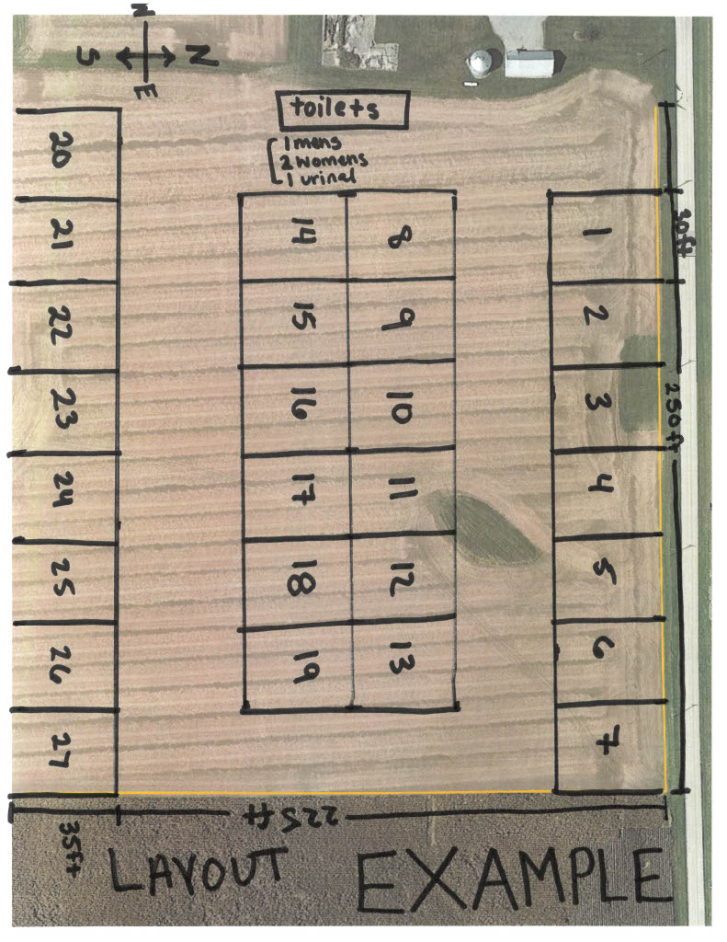

**Appendix 2**

**Proposed Layout Example**

*Created using Google Earth

Check the following:

* Site sizes are clearly marked (our example uses the recommended 30ft by 35 ft. size)
* Toilet location and numbers are clearly marked.
* Designate one site as the location of the site manager for the entirety of the event.
* All of the sites are accessible by a drivabale pathway that can fit an ambulance, we started with 30 foot pathways and made them a little larger based on the space available.

**Vicinity Map Example**

**Appendix 3**

*Created using Google Maps screen capture

Check the following:

* All access roads to the site are visible.
* The roadway names are visible.
* List the closest address to the lot. Include directions from that address to the lot you will be using.

**Appendix 4**

**Rules Example**

1. Traffic control;
   * Maximum vehicle speed within the park area is 10 MPH. No parking permitted on established roadways within park so that clear access is maintained for emergency vehicles.
   * All recreational vehicles must be parked maintain at least 15 feet side to side spacing between units, including slide-outs, and 10 feet end to end or end to side.
2. No excessive noise is permitted within park after 10:00 PM
3. All fires must be contained in fire rings and are only permitted in established areas.
4. No fireworks permitted within park. No use of firearms permitted within park.
5. All water hoses used for human consumption in a temporary park-camp must be rated for potable water use only.
6. All solid waste be placed in appropriate containers with tight fitting lids.
7. All sewage and graywater must be contained within each vehicle and/or properly disposed to prevent potential nuisances.
8. All pets must be registered with the campground manager upon arrival. All pets must be leashed and are not permitted to run at large within the campground. Owners must immediately clean up after pets.

**Appendix 5**

**Fire Authority Letter Example**

Dear [Fire Authority],

I plan to have a temporary campground park at [campsite address] on the dates of [dates of event]. There will be [##] lots at the temporary campground during this event.

Attached is a copy of the plans for the layout of the campsites. Please review the plans and provide a letter of approval to [your address or email address].

Thank you for your consideration,

[Signature]

[Your Name]

[Your Address]

[Your phone number]

[Your Email]

**Appendix 6**

Fire Authority Contact Information

**Upper Sandusky Fire Department**

Phone: 419-294-3322

Address: 120 N. 7th Street, Upper Sandusky, OH, 43351

**Harpster Fire Department**

Phone: 740-496-2735

Address: 7276 Wyandot Street, Harpster, OH 43323

**Sycamore Volunteer Fire Department**

Phone: 419-927-2900

Address: 106 E 7th Street, Sycamore, OH 44882

**Carey Village Fire Department**

Phone: 419-396-7400

Address: 127 N. Vance Street, Carey, OH 43316

**Wyandot East Fire District**

Phone: 740-482-2475

Address: 200 Grant Street, Nevada, OH 44849

**Forest Fire Department**

Phone: 419-273-2520

Address: 211 W. Lima Street, Forest, OH 45843